**Delyar Tabatabai**

**Project 5**

[**tabatase@oregonstate.edu**](mailto:tabatase@oregonstate.edu)

**Video:** [**https://media.oregonstate.edu/media/t/1_592yplf7**](https://media.oregonstate.edu/media/t/1_592yplf7)

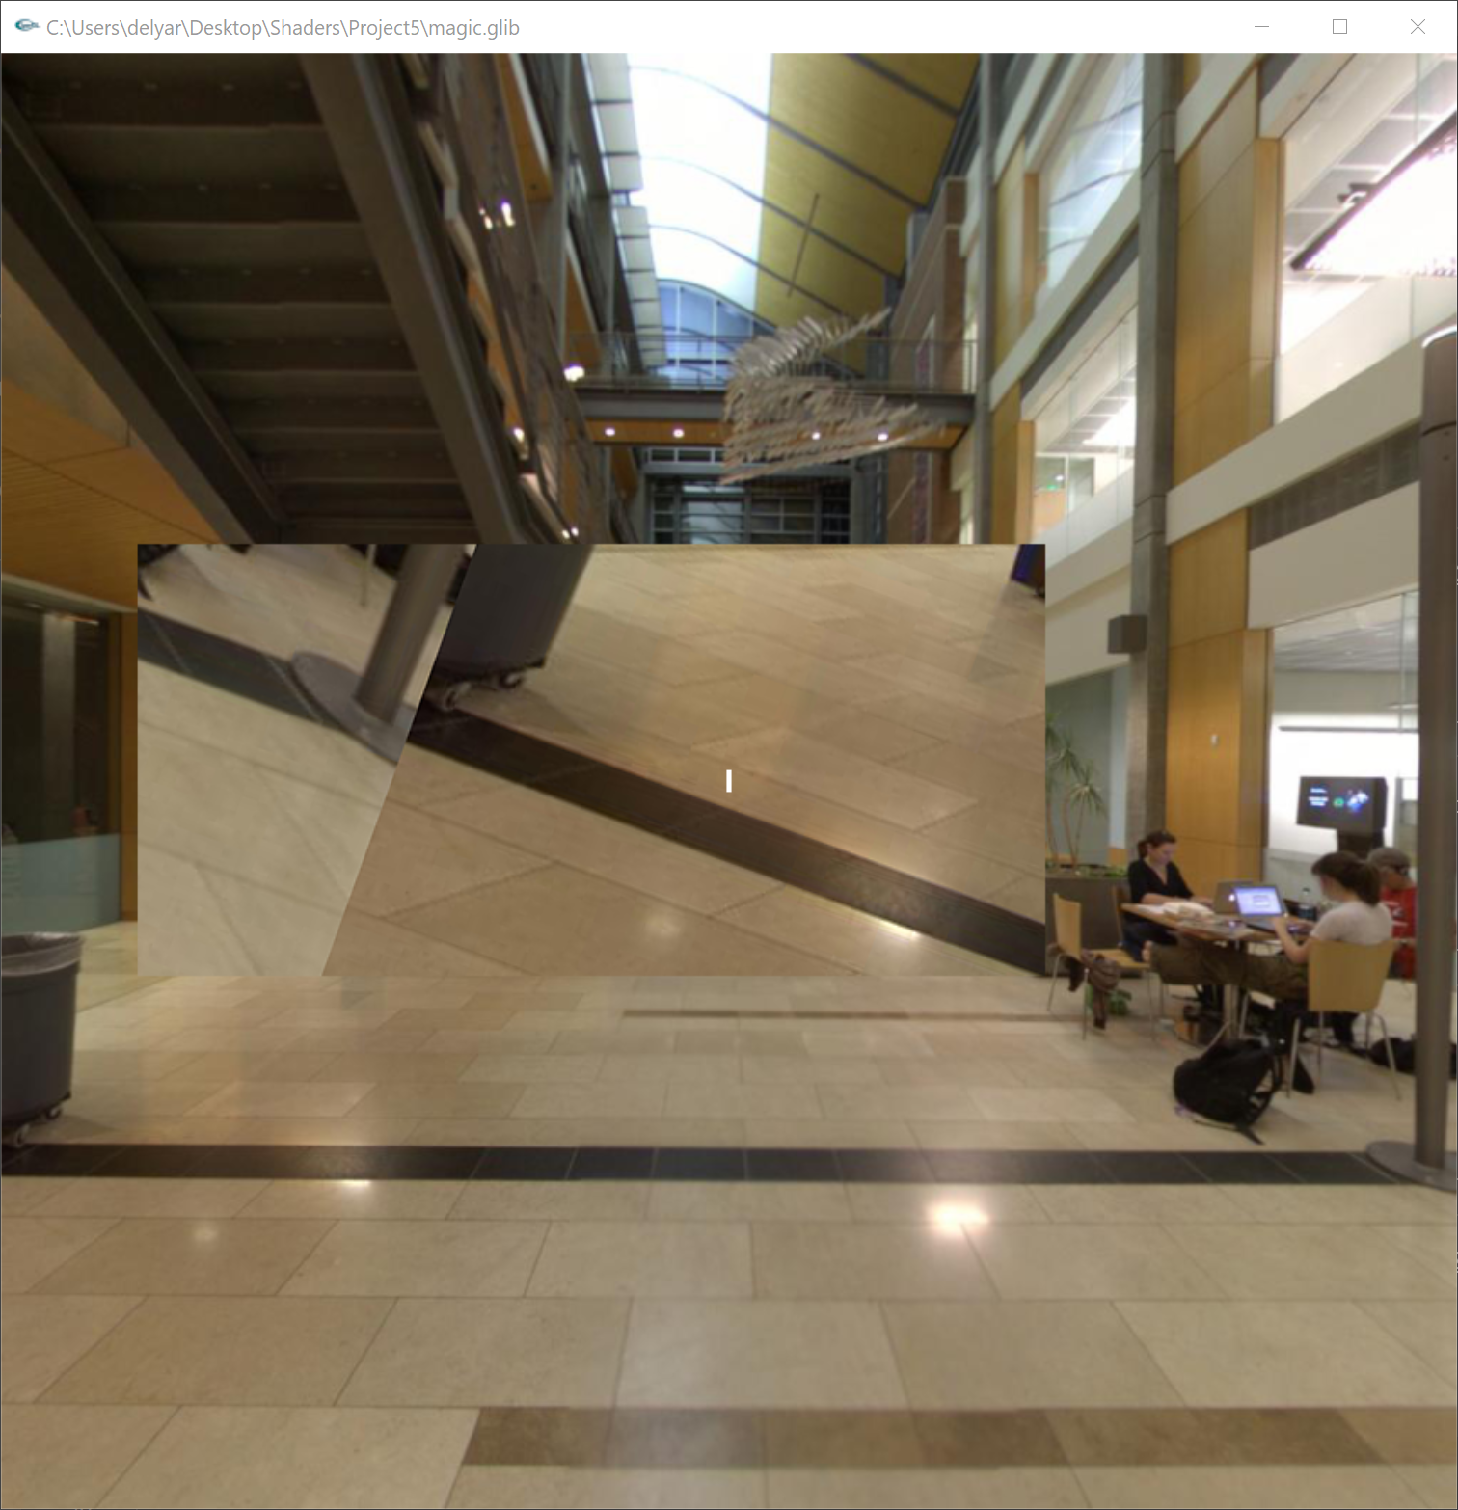

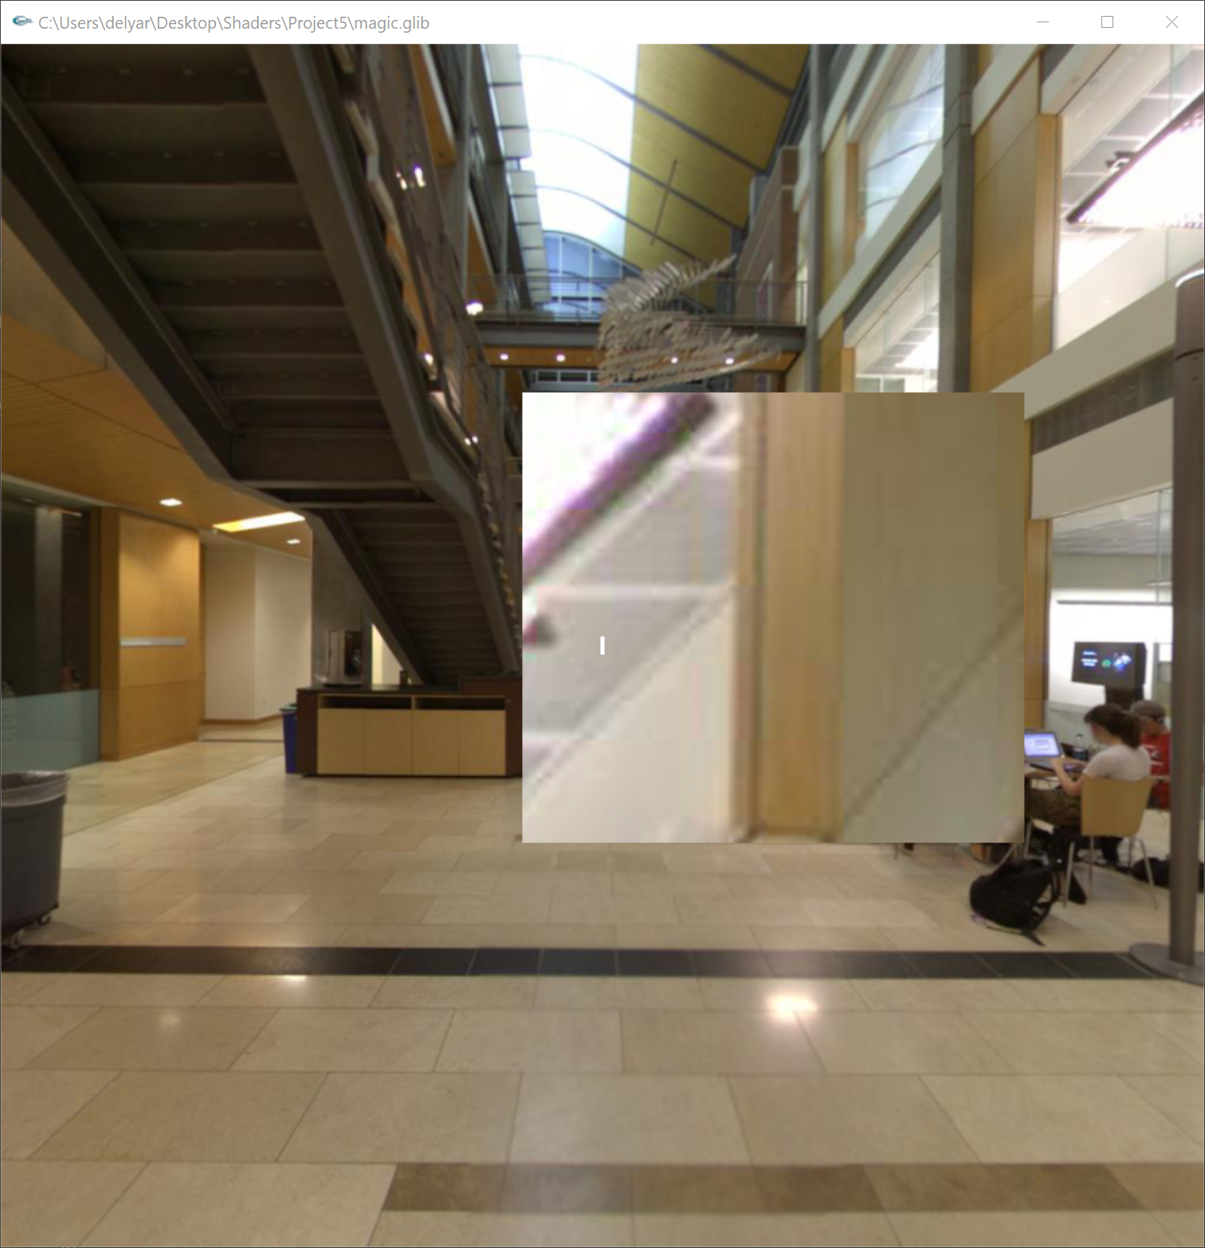

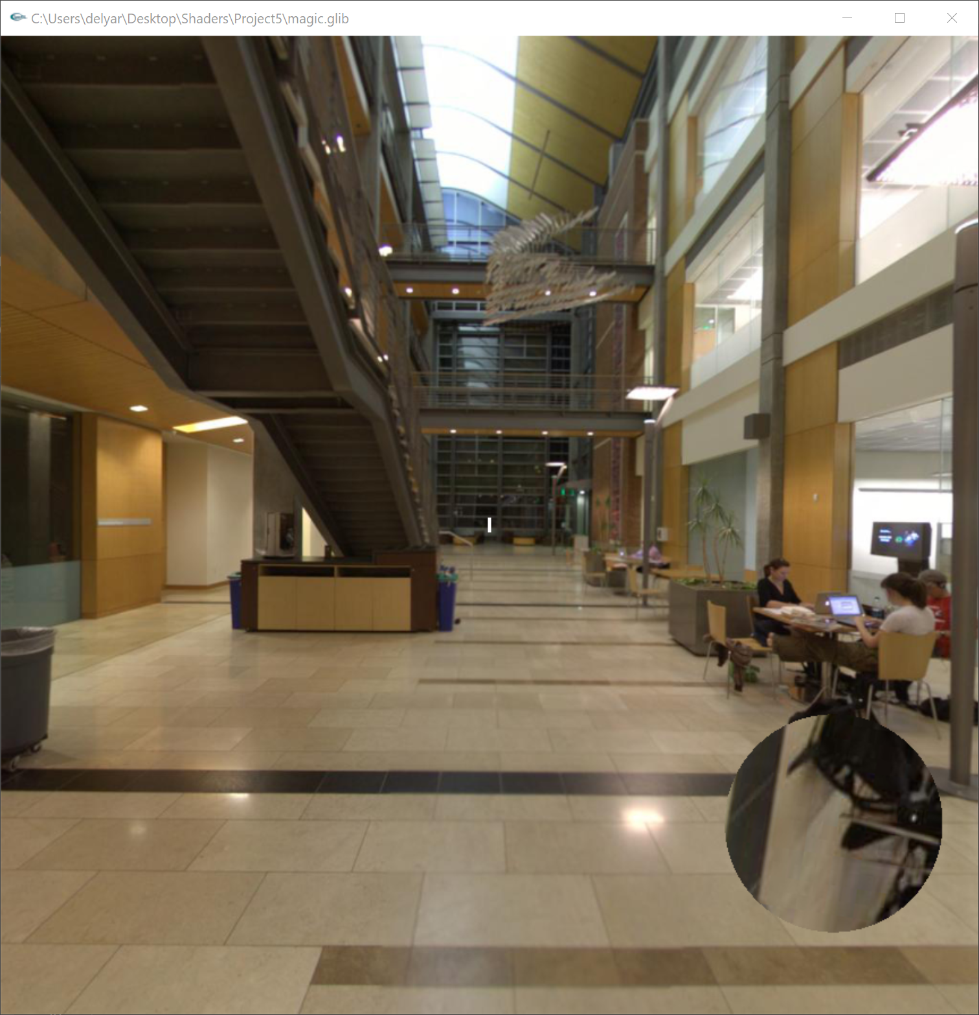

**Sharpened vs blurred:**

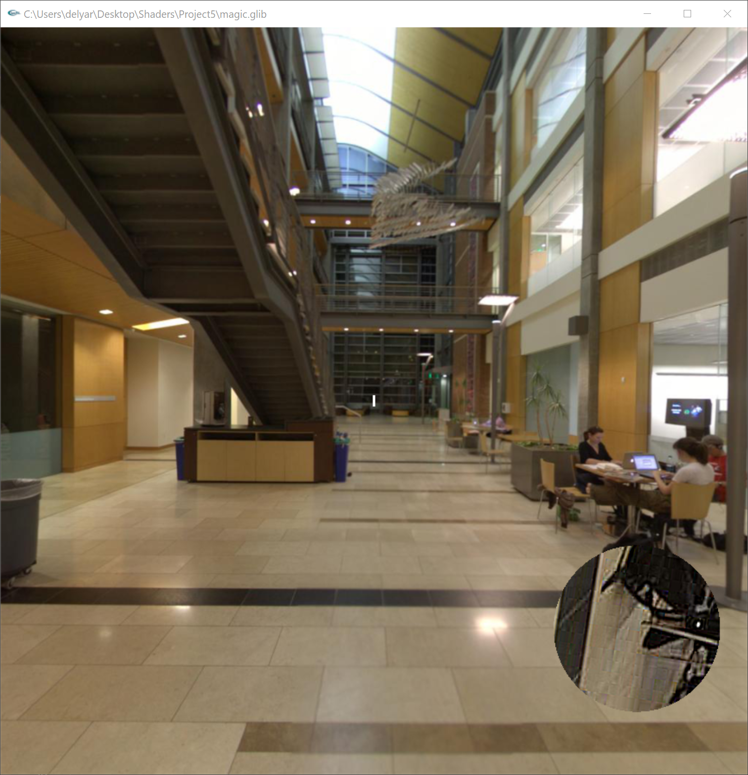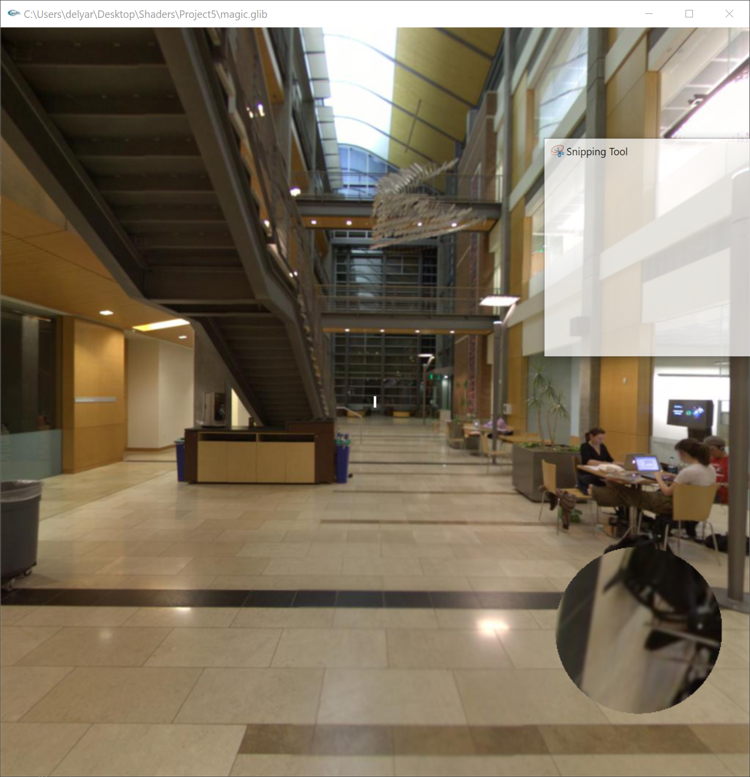

**Using sobel:**

